 | 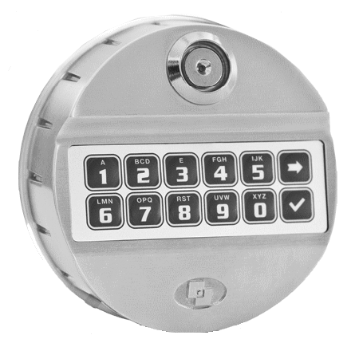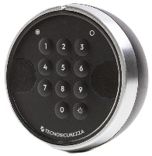 |  | 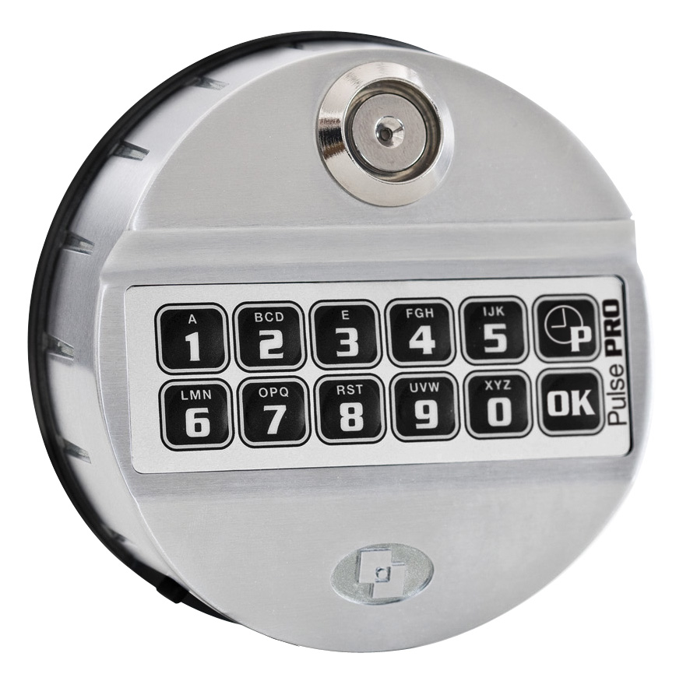 | 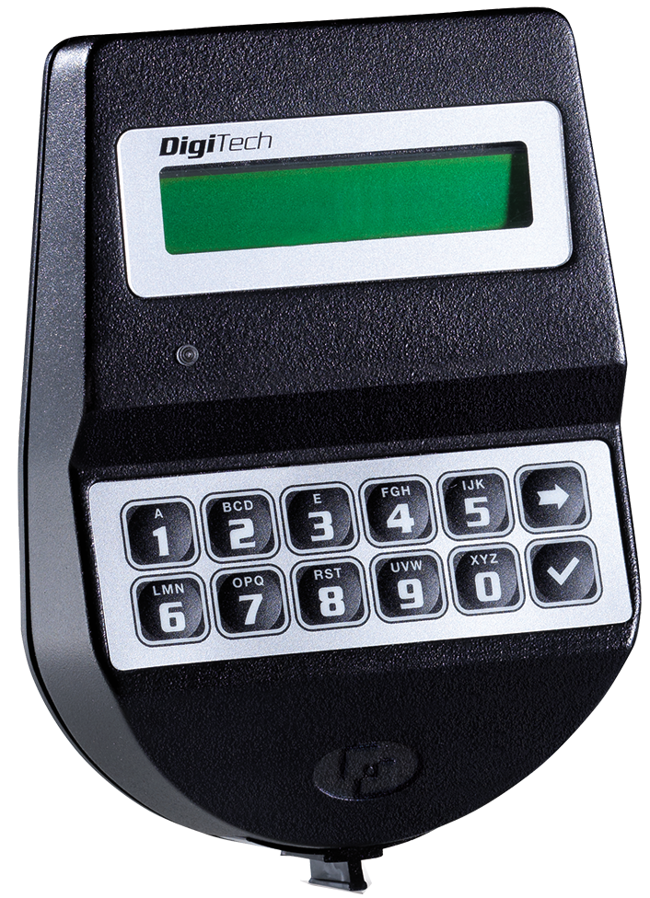 | 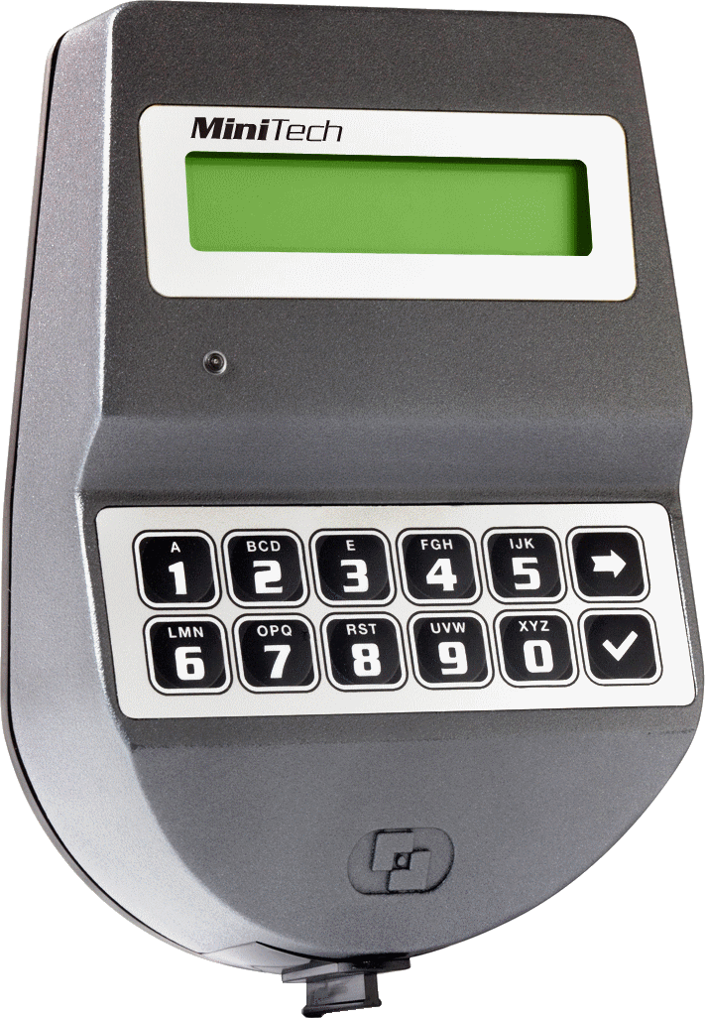 | 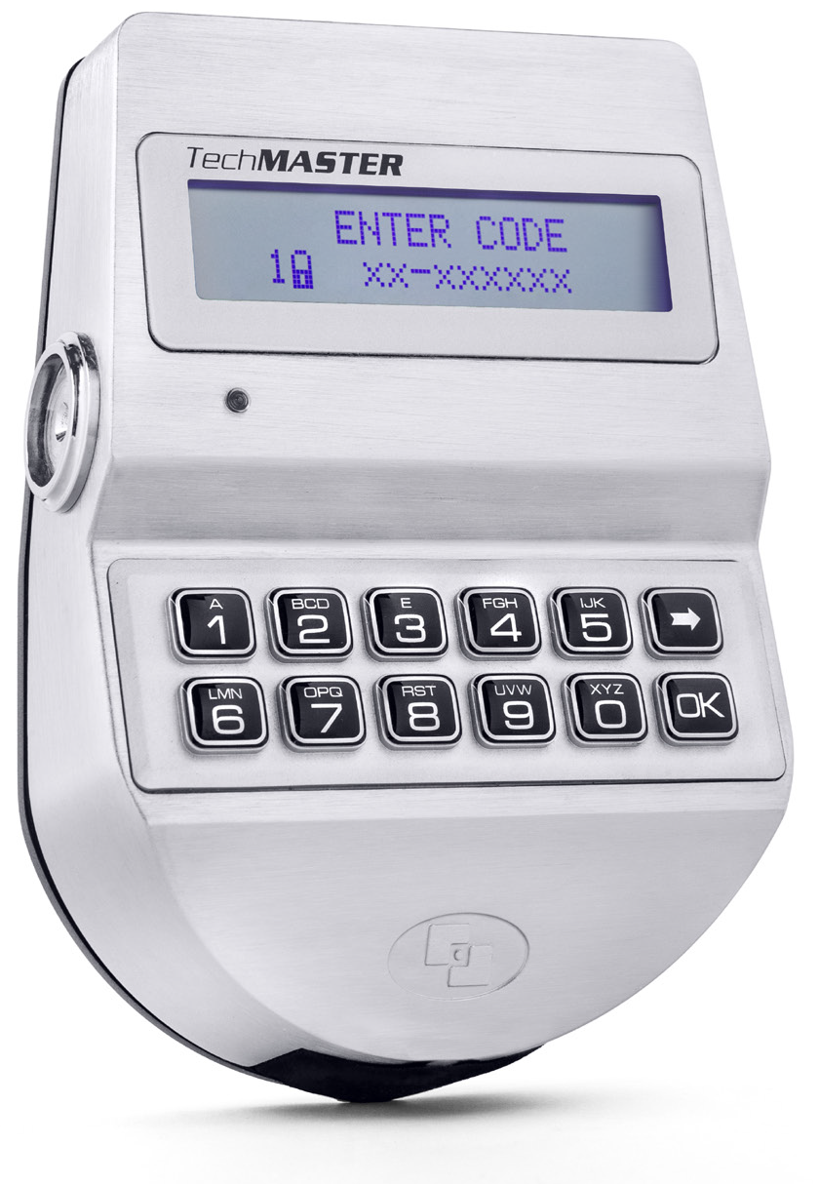
 | Pulse / Pulse Next  2 users | Pulse / Pulse Next  10 users | Pulse PRO | DigiTech | MiniTech | TechMaster
Power Supply | 9V Battery  Large Battery Box  12V power supply | 9V Battery  Large Battery Box  12V power supply | 9V Battery  Large Battery Box  12V power supply | 9V Battery  Large Battery Box  12V power supply | 9V Battery  Large Battery Box  12V power supply | 9V Battery  Large Battery Box  12V power supply
Users | - 1 Manager  - 1 User | - 1 Manager  - 8 Users | - Up to 2 Masters  - Up to 2 Managers  - Up to 49 Users | - 1 Manager  - Up to 28 Users | - 1 Master  - 1 Manager  - Up to 48 Users | - Up to 2 Masters  - Up to 2 Managers  - 1 Override Manager  - 1 Administrator  - 89 Users
Override user |  | 1 User* | Up to 10 Users | 1 User* | Up to 10 Users* | Up to 80 of the users, available in groups*
Time delay | 1-99 minutes | 1-99 minutes | 1-99 minutes | 1-99 minutes | 1-99 minutes | 1-99 minutes  Variable Time Delay*
Dual mode* |  | Available | Available | Available | Available | Available (in groups)
Dallas keys* |  | Available | Available | Available | Available | Available
Audit* |  | 100 events  w/o time and date | - Up to 8.000 events with time&date  - Automatic DST | - Up to 8.000 events with time&date  - Audit display  - Automatic DST | - Up to 11.000 events with time&date  - Audit display  - Automatic DST | - Up to 15.000 events with time&date  - Audit display  - Automatic DST
Interface* |  | - Silent alarm  - Remote disable opening | - Silent alarm  - Remote disable opening  - Remote time delay override | - Silent alarm  - Remote disable opening  - Remote time delay override | - Silent alarm  - Remote disable opening  - Remote time delay override | - Silent alarm  - Remote disable functions  - Remote management (TCP/IP, RS485)
Time lock |  |  |  |  | - Weekly opening and closing  - 60 between closing and opening periods  - Immediate & temporary time lock  - Time programmed from the keypad or a PC | - 3 users tables, each with weekly opening and closing  - 60 between closing and opening periods  - Immediate & temporary time lock  - Time programmed from the keypad or a PC  - Opening extensions
Advanced features* | - Backlit keypad (Pulse Next)  - Slim version (Pulse Next) | - Backlit keypad (Pulse Next)  - Slim version (Pulse Next) | - Battery level test  - Fully configurable by keypad (more than 80 configurations)  - Codes expiry*  - Door open alarm*  - Bolt status output*  - ERC – Emergency Rescue Code* |  | - Dynamic Codes  - Multiple locks: 2 | - Dynamic codes  - Codes expiry  - Multiple locks: 15
Certifications |  |  |  |  |  | 

All locks systems have penalty and low battery warning
*Optional features available with additional hardware and/or as a programming request when purchased

